Remote Inspection by Video Guide:
Uploading Recorded Video Inspections
Provided by:
Collier County Growth Management Department
Development Services

May 1, 2020
The Remote Inspection by Video Program was launched in response to COVID-19 guidelines for social distancing to protect our residents, contractors and inspectors. Essentially, the program allows permit holders to record a video of their work and submit it electronically to the County’s licensed inspectors for review.

Is recorded video right for your business?
Requires Program registration and training before beginning to upload.
This process, capturing a video for later review by an inspector, has some advantages and some disadvantages.

Advantages:
- Makes video inspection available where cell phone/tablet/pc connections are poor or non-existent.
- Can be recorded when the work is done; no trip back to the job site to meet an inspector.
- Makes review of the work by supervisors possible without a site visit; catch problems before an inspection failure adds cost and time.
- Support social distancing and reduces the number of person-to-person contacts.

Disadvantages:
- Some technical challenges exist when moving large video files around.
- Staff training will be needed to learn the tools that fit your business model.
- Some investment may be required to build a robust process that saves you time rather than costing you time!

why we developed this guide
To show a variety of workflow models to help companies find the right solution for their business.
This guide was developed to help the less tech savvy of us out there to understand the technical solutions available to help facilitate the Recorded Video Inspection Program. We know that no two businesses operate the same. As such, it is difficult for us to provide direct instructions on how to make the Recorded Video Inspection Program work for your exact business model. Our aim with this guide is show you a variety of workflow models that may work for your company. The workflows depicted below are the most common workflows that we believe are inexpensive and easy to implement given the requirements of the program. All the workflows are designed around the requirement that only individuals named on the Qualifier Compliance Affidavit used for program registration are permitted to upload videos to the County’s BOX.
In the following pages, we will go over the five workflows and some of the available technological options for making these workflows work. If your volume of recorded video inspections is low, then all of these workflows can be implemented free of charge. If you have a high volume of recorded video inspections, some of the cloud storage options may require a small capital investment.

At the end of this document we have provided a reference guide of some of the common technological options available to support these workflows. The technical reference guide contains both a link to where you can find more information about the technology and how you can set them up.
This guide is intended to show some of the ways a company might use the equipment they have now to successfully deliver recorded videos to the program’s BOX account. The software and hardware mentioned is for example only; individual companies are solely responsible for selecting the business tools that meet their individual needs.

The Workflow Options
Click the “link” below each model to take you to more detailed information

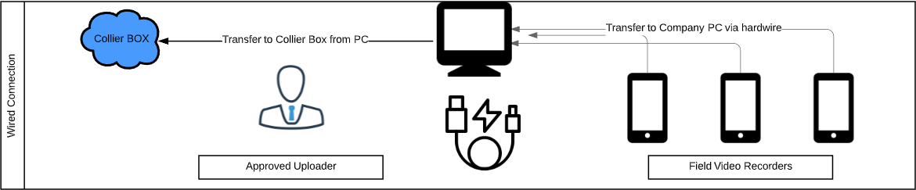
The Wired Workflow

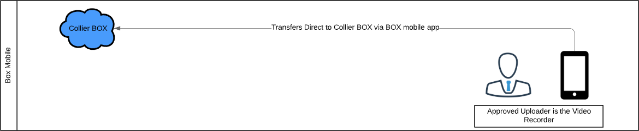
The BOX Mobile Workflow

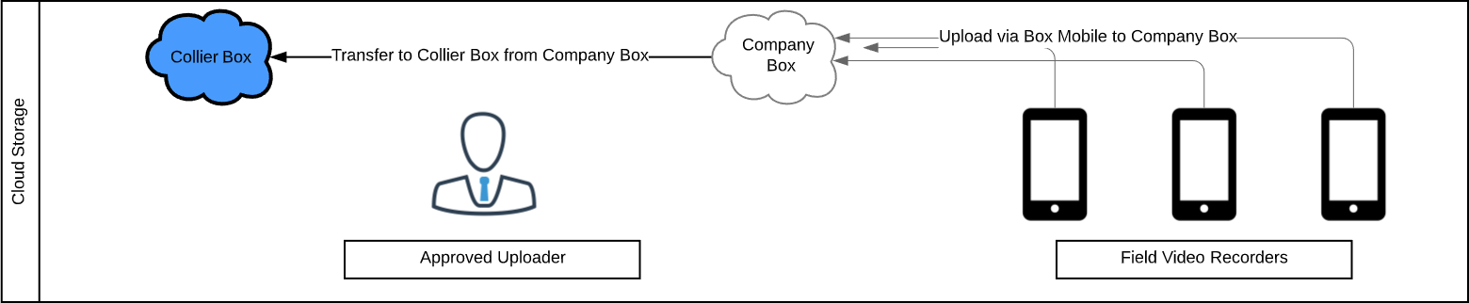
The BOX Account Workflow

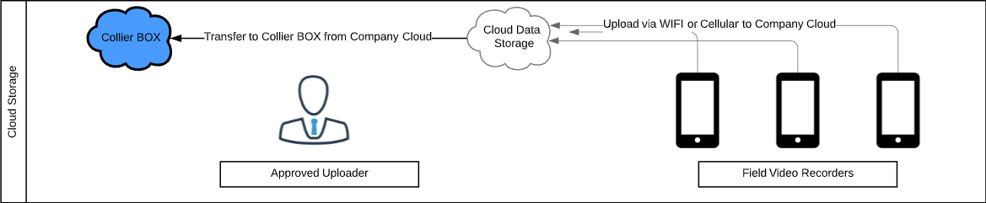
The Cloud Storage Workflow

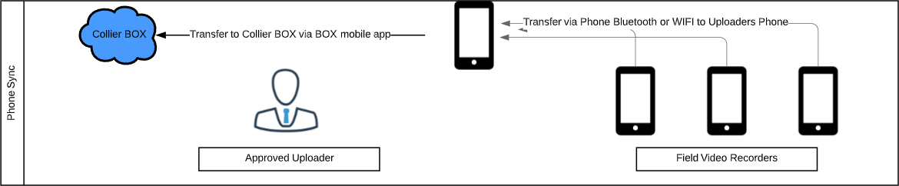
The Phone Sync Workflow

Wired Connection

Overview:
The wired connection workflow is the simplest to implement, as most business already have all of the required components. This will work with any make or model of smart phone or computer. The hardwire used for the connection is usually provided with the purchase of a new smart phone.
Who is this best for:
- Approved Uploaders who operate off a laptop or desktop that have internet connectivity
- Companies where staff regularly return to the location where the Approved Uploader works
- Companies with smart phones deployed to the field
- A low volume of videos uploads per week

The Workflow:
Record video on Smartphone. Plug your phone into your computer using the cable that comes with the phone to transfer the files. Rename the files on the computer. Lastly, transfer the files to BOX from your computer
Things to watch for:
- Smart phones deployed to the field will occasionally need to delete videos to preserve memory
- Some phones will require you to install software on your computer in order to access the photos and videos on the phone

Technology Requirements:
- Computer
  - Any make or model
  - Laptop, tablet, or desktop will work
  - IOS or Android
- Smart phone
  - Any make or model
  - IOS or Android
- Smart phone cable
  - Hardwire compatible with phone and compatible open port on computer

Box Mobile
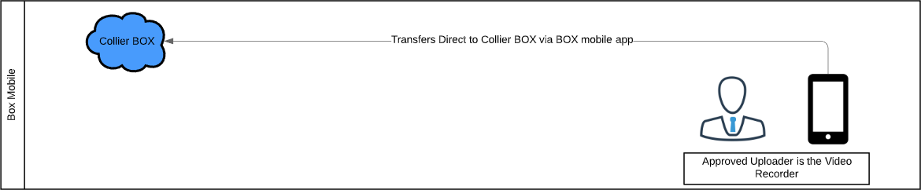

Overview:
The BOX Mobile workflow is the most streamlined workflow available. The BOX Mobile software is available for both IOS and Android devices and will enable you to upload your recorded videos from the same device that you record your videos on. BOX Mobile is free to use and only requires that you create a free public account. Once you are invited as a collaborator to Collier’s BOX account you will be able to upload directly to it through BOX Mobile.
Who is this best for:
- Approved Uploaders who also record the inspection videos

The Workflow:
Record video on smart device. Rename the video to the appropriate name. Open the BOX Mobile app and select the recorded video to upload.
Things to watch for:
- Uploading recorded videos from a smart device will consume cellular data unless you are on WIFI
- Smart devices deployed to the field will occasionally need to delete videos to preserve memory
- The process for renaming videos and photos can vary between devices and some may require a video editing app to do this

Technology Requirements:
- Smart Device
  - Any make or model
  - IOS or Android
- BOX Mobile App
  - IOS or Android
- Video editing App
  - Only needed if your device doesn’t support file renaming

BOX Account
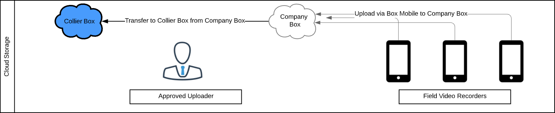

Overview:
The BOX Account workflow can work for any organization whether large or small. This workflow does require a paid subscription to BOX, but the resulting workflow ends up being one of the simplest to navigate. The workflow avoids having to download videos from the cloud, as videos can be uploaded to BOX via BOX Mobile and viewed, renamed, and transferred directly from your Company BOX to our Collier BOX. This workflow can be completed entirely on smart device if needed.
Who is this best for:
- Distributed workforces who infrequently visit an Approved Uploader.
- Producers of large volumes of video uploads per week
- Approved Uploaders who have network limitations at their work location
- Approved Uploaders who desire an easy solution with minimal time commitments

The workflow:
Field staff record video on smart device. Field staff upload videos directly to their Company BOX via BOX Mobile. Rename the video to the appropriate name in Company BOX. Approved Uploader transfers directly from their Company BOX to the Collier BOX.
Things to watch for:
- Regularly deleting items from your BOX account to stay under your data limit.
- Uploading recorded videos from a smart device will consume cellular data unless you are on WIFI
- Smart devices deployed to the field will occasionally need to delete videos to preserve memory

Technology Requirements:
- Computer or Smart Device
  - Any make or model
  - Laptop, tablet, or desktop will work
  - IOS or Android
- BOX Subscription
  - BOX’s free account data limits are too low for video uploads
- BOX Mobile App
  - IOS or Android

Cloud Storage
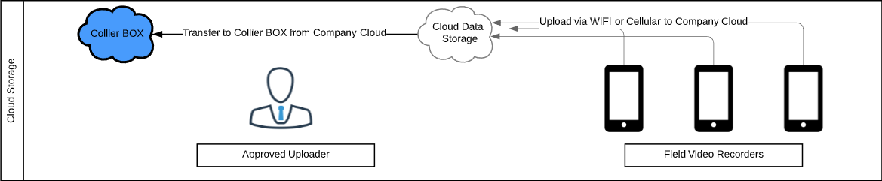

Overview:
The Cloud Storage workflow can work for any organization whether large or small. This flow utilizes any cloud storage company that is not BOX and this is due to the fact that competing cloud companies do not allow for seamless transfer of data between them. For small organizations this workflow can achieved free of cost, while large organizations may have a minimal cost depending on their video inspection volume. This workflow requires either the use of Link Sharing, Cloud Transfer software, or downloading the data from your Company Cloud to upload it to the Collier BOX. More info about these items can be found in the reference guide provided in the back of this guide.
Who is this best for:
- Distributed workforces who infrequently visit an Approved Uploader.
- Producers of large volumes of video uploads per week
- Approved Uploaders who have network limitations at their work location
- Businesses that already have a Company Cloud subscription

The workflow:
Field staff record video on smart device. Field staff upload videos directly to their Company Cloud via an app on their smart device. Rename the video to the appropriate name in the cloud. Approved Uploader transfers from their Company cloud to the Collier BOX via Link Sharing, Cloud Transfer software, or downloading the data from your Company Cloud to upload it to the Collier BOX.
Things to watch for:
- To transfer between disparate clouds, you will either need to use Link Sharing, Cloud Transfer software, or downloading the data from your Company Cloud to upload it to the Collier BOX.
- If you are using a free cloud account, you will need to regularly delete items to stay under your free limit.
- Each cloud provider offers different limits on upload size and free storage amounts. These are listed on our reference at the back of this guide.
- Uploading recorded videos from a device will consume cellular data unless you are on WIFI
- Smart devices deployed to the field will occasionally need to delete videos to preserve memory on the devices

Technology Requirements:
- Computer
  - Any make or model
  - Laptop, tablet, or desktop will work
  - IOS or Android
- Smart device
  - Any make or model
  - IOS or Android
- Cloud subscription
  - Can be any cloud storage provider
- Cloud app on smart device
  - From your cloud storage provider
- Cloud transfer software
  - Several vendors exist to facilitate transfer between disparate clouds

Smart Device Sync
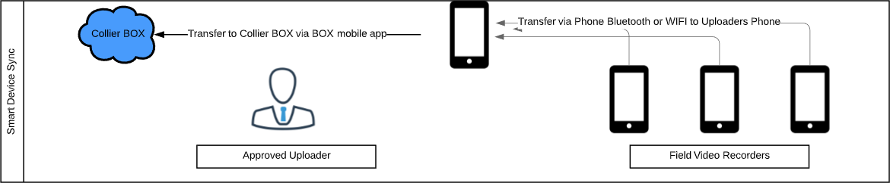

Overview:
The Smart Device Sync workflow supports an entire data transfer workflow with smart devices. Modern smart devices support functionality that allows them to transfer data directly between each other without the need for cellular or a WIFI connection. Devices only need to be within range of another supported devices and a transfer can occur.
Who is this best for:
- Approved Uploaders who operate off a smart device
- Approved Uploaders who frequently meet with Field Video Recorders to collect videos
- Companies with smart devices deployed to the field
- A low volume of videos uploads per week

The Workflow:
Record video on smart device. Ensure the sync technology is enabled on both devices. Turn on the sync software. Find the receiving device and select the files you want to transfer to the device. Approved Uploader uses BOX mobile to transfer received files to Collier BOX.
Things to watch for:
- Smart devices deployed to the field will occasionally need to delete videos to preserve memory
- Sharing technology usually requires you to be within 25 feet of the other device
- Ensure transfers are complete before leaving connection range

Technology Requirements:
- Smart device
  - Any modern make or model
  - IOS or Android
- Smart device synch software
  - IOS and Android have different solutions

Technical Reference Guide

Cloud Storage Options
Used to store data and facilitate link sharing via the cloud
Name | Product Page |  | Tutorials
- Dropbox | Link |  | Link
- Google Drive | Link |  | Link
- Microsoft OneDrive | Link |  | Link
- BOX | Link |  | Link
- iCloud | Link |  | Link
- Send Anywhere | Link |  | Link
Comparisons Link or Link

Cloud Transfer
Used to transfer data from one brand to cloud to another.
Name | Product Page |  | Tutorials
- MultiCloud | Link |  | Link
- pCloud | Link |  | Link
- CloudFuze | Link
Comparison: Link

Smart Device Sync – Android
Used to transfer data direct from device to device
Name | Product Page |  | Tutorials
- Samsung File Sharing | Link |  | Link
- Send Anywhere | Link |  | Link
Comparison Chart: Link

Smart Device Sync – IOS
Used to transfer data direct from device to device
Name |  | Product Page | Tutorials
- Air Drop |  | Link | Link

Video Editing Apps – Android
Used to rename videos, edit lengths, or add photos into videos
Name |  | Product Page | Tutorials
- PowerDirect |  | Link | Link
- In Shot |  | Link | Link
- You Cut |  | Link | Link
Comparison Chart: Link

Video Editing Apps – iOS
Used to rename videos, edit lengths, or add photos into videos
Name |  | Product Page | Tutorials
- iMovie |  | Link | Link
- Splice |  | Link | Link
- Adobe Premiere |  | Link | Link
Comparison Chart: Link

Video Pausing Apps – iOS
Used to pause video recordings without having to create a new video
Name |  | Product Page | Tutorials
- Video Cam + Pause |  | Link
- Pause Video |  | Link
- Vid Fuze-Video Cam |  | Link

Video Pausing Apps - Android

Video pausing is a standard feature on Android phones.

iOS Guides
Items that are unique to iOS workflows
Name |  | Product Page | Tutorials
- iPhone |  | Link
- iTunes |  | Link
- iOS hardwire to Computer |  | Link

Android Guides
Items that are unique to Android workflows
Name |  | Product Page | Tutorials
- Android hardwire to Computer |  | Link | Link

