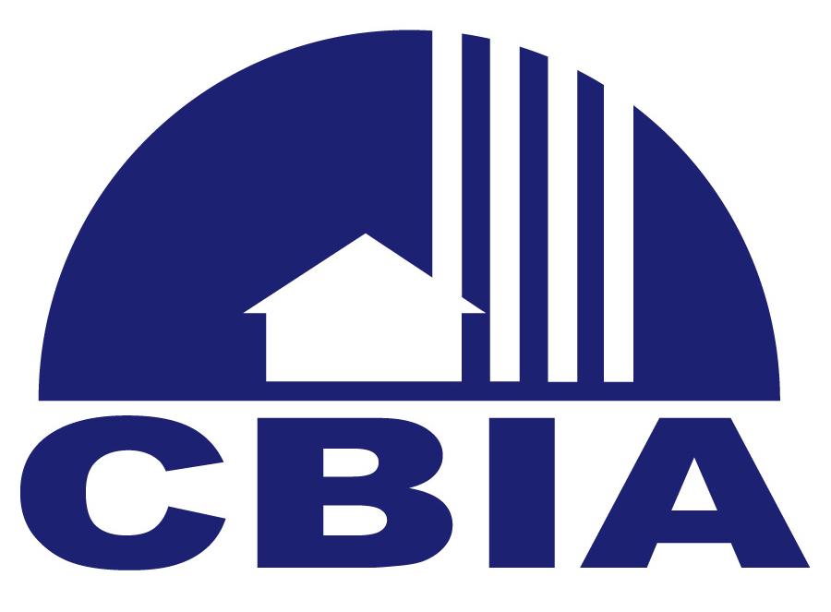

2017 Committees

 Ambassador Retention Membership Committee (ARM) – Chair: Julio Barina, Markham Norton Mosteller Wright & Company, ARM Committee members act as ambassadors welcoming and introducing new members to our leadership at various events. ARM Committee meets on an ad-hoc basis.
Meets Quarterly at Shula’s following CBIA “New Member Orientation Breakfast.)

 Finance Committee – Chair: CBIA Interim Treasurer, Kevin Deardorff, Weibel, Hennells and Carufe, PLLC. Finance committee members ensure the Association's expenditures stay in line with the budget. Made up of member CPA's and finance professionals and meets every month throughout the year.
Meets monthly: third Thursday of each month 8:00 a.m. at CBIA except July and December.

 Golf Committee – Chair: Ben Buemi, HBK CPA’s and Consultants
Organizes the annual spring and summer golf outings, assists with sponsorships, companion buffet lunches and awards ceremonies. BYO lunch meetings from March –August. .
.
 Governmental Affairs Committee – Chair: Ryan Benson, A. Vernon Allen
Monitors local, state and federal legislation and provides research on pending legislation that affects the building industry. Meets generally the third Thursday of the month 4-5:00 p.m. at CBIA.

 Parade of Homes® Committee – Chair: Jackie Nelson, Clive Daniel Home
Committee members assist with recruiting sponsors, builder participants, driving judges, and the awards breakfast. Committee will begin meeting in late fall.
Meetings run October 2017 through March 2018. Day and time for monthly meetings will be determined at the first meeting in October each year.

 Sand Dollar Committee – Chair: Karen Gomez, The Lykos Group, Vice Chair Minka McDonald, Jinx McDonald Interior Designs, Inc. Committee members assist with all aspects of planning and implementation of annual SD awards.Meetings are scheduled monthly, February – October 2017, the first Wednesday of each month from 9:30-10:15 a.m. 2018 Committee will begin meeting in February 2018.

 Toy Drive Committee – Co Chairs: Kaleigh Grover (Naples Illustrated, Debbie Cross, Belz Properties. Committee members assist with all aspects of planning and implementation of annual Toy Drive which includes helping with sponsorships, wrapping and delivering boxes to member locations, sorting toys, preparing staff gifts, shopping for toys, helping give toys out at each of the designated schools..
Meetings are scheduled September – December of each year.

2017 TASK FORCE GROUPS

 CBIF Action Plan – Chair: TBD
This group will develop an action plan for matching and spending funds relative to education initiatives to benefit the construction industry. Meetings begin in February and meet until work is completed. This committee has completed their work and will present findings to the CBIA-BOD at their August 2017 meeting.

Please  the committees you would like to serve on and return this form to:

CBIA, 3200 Bailey Lane, Suite 110, Naples, FL 34105,
email to nancy@cbia.net or fax 239-436-3878. We’ll follow-up via email.

CBIA is a team effort and your participation makes the association stronger – there is strength in our numbers! Joining a committee is a great way to network with and meet other CBIA members.

NAME: _______________________________________________________________________________________

COMPANY: ___________________________________________________________________________________

PHONE: ______________________________________________ FAX:___________________________________

EMAIL: _______________________________________________________________________________________

