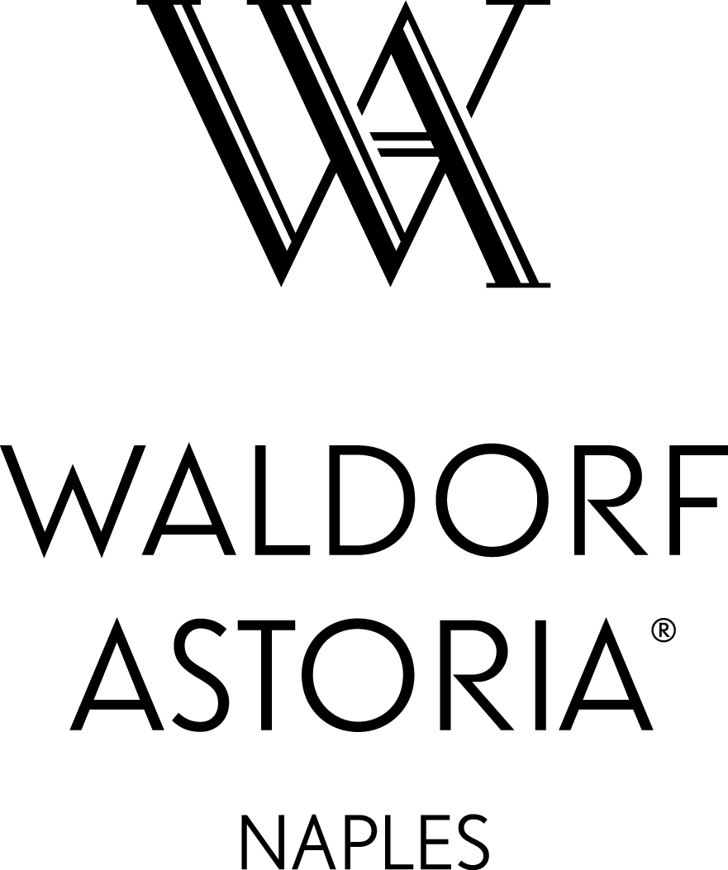
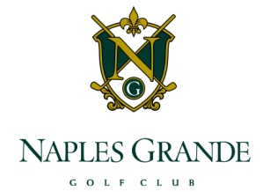
Waldorf Astoria Naples
March 14, 2014
Naples Grande Golf
Open Position Listing – March 14, 2014

Management:
Asst Restaurant Manager
Leisure Sales Manager
Asst Golf Superintendent

Housekeeping:
(1) House Attendant-FT
(3) Room Attendant - FT
(1) House Attendant Supervisor-FT
(1) Room Attendant Supervisor-FT

Sales/Events/CATERING:
- Social Catering Coordinator - FT
- Executive Meeting Manager - FT

Spa:
(1) Spa Attendant-PT
(1) Massage Therapist - FT
(1) Lead Nail Technician - FT

Guest Services:
(1) Front Desk Supervisor-FT
(2) Front Desk Agent –FT
(1) Concierge – OC
(1) Overnight Bell Attendant – OC
(1) PBX Operator-FT

Positions highlighted in yellow are designated as “high need” and have a referral bonus attached.
CAREER OPPORTUNITIES
WWW.HILTONWORLDWIDE.COM/CAREERS
**website is most current, up-to-date listing of available positions**
All applications must be submitted through our electronic, on-line system.

For office hours or assistance, call the HR department at 239-254-5685.
Hilton Worldwide is an EOE/AA M/F D/V employer.

We proudly support our US Military! Special consideration is given to applicants who are
US Military Veterans, Active Duty Reservists/Guards and families of active duty military personnel

Property Operations:
(1) Electrician/Mechanic –FT
(1) General Maintenance – FT

Food and Beverage/Recreation:
(1) Beach Concession Attendant-FT
(1) Rooms Service Server-FT
(1) Banquet Food Runner – FT

Culinary:
(1) Cook I-FT
(2) Cook II-FT
(1) Cook III-FT

Golf Course:
(1) Cook II – Seasonal

Internships (College Credits):
Guest services rotation
PBX/Concierge/Front Desk
Resort concierge rotation
Spa/Golf/Tennis Concierge

Highlighted positions qualify for Referral bonus

Applying for positions at the

Waldorf Astoria Naples and

Naples Grande Golf Club

Step 1: Log onto www.hiltonworldwide.com/careers
Step 2: On the right side of the page under “Find a Job” click United States and chose your language.
Step 3: You will be brought to the “Careers” search page. Click the link for “Basic Search”.
Step 4: On the Job Search page, select the link for “ALL LOCATIONS - UNITED STATES” and click on NAPLES.
Step 5: You will be brought to an opportunities listing page. Click on any job title to see more information.
Step 6: Click on the job title to view the detailed job description.
Step 7: Click the “Apply” button at the bottom left of the job posting and register as a new user on the website.
Step 8: Create and enter your username and password. Confirm that you are not a current Hilton Team member.
Step 9: You may either upload a resume or you may proceed to apply without uploading a resume. You will also need to complete the application – filling in all blanks (including work history, salary required, reason for leaving, etc.) to be considered.
NOTE: The on-line application has nine sections: Resume Upload, Personal Information, General Questionnaire, Qualification Questions, Basic Profile, Experience & Qualification, Attachments, Diversity, & Summary. Once you “submit” your application, you may not go back in to make changes, please review and ensure that all sections are complete prior to sending it in to us. Note that the Submit button will not be enabled until you have completed each page and then scrolled to the bottom of the Applications Review page. However, you may go back to edit your Resume & Personal Information at any time.

Step 10: After you complete, review and submit your application, you will be taken to the “My Career Tools” page where you can see which position(s) you have applied for. Be sure to log out to save your personal data.

The Waldorf Astoria Naples and the Naples Grande Golf Club are proud members of the Hilton Worldwide family of Hotels and Resorts. We pledge full support to the Affirmative Action Program and policy of nondiscrimination and equal opportunity, in compliance with Executive Order 11246, as amended, as well as applicable state and local laws. The properties recruit, hire, train, and promote persons in all job titles without regard to race, color or creed, religion, ancestry, national origin, sex, sexual preference, disability, age, marital status or status with regard to public assistance. Applicants may view the plan at Human Resources at 475 Seagate Drive.
Hilton Worldwide is EOE/AA M/F D/V employer.
Revised: 10/2013

______________________________________

We proudly support the U.S. Military!
In accordance with the US Government initiative to help our military service men and women find gainful employment when they discharge from any branch of the US Military, Hilton Worldwide, Inc., the Waldorf Astoria Naples and the Naples Grande Golf Club endeavor to help re-employ our military heroes. As a result, Hilton Worldwide has pledged to employ 10,000 military veterans, active duty and families over the next five years. Applications which indicate that they fit into one of these categories will be given preferential screening in our applicant data base. Thank you to those who serve our country!

